claasification Assignment2

JADHAV PAYAL RAVINDRA

ROLL NO. 2404

06-09-2025
library(MASS) # For LDA and QDA
library(class) # For kNN
library(e1071) # For Naive Bayes
## Warning: package 'e1071' was built under R version 4.4.3
library(caret) # For confusion matrix
## Warning: package 'caret' was built under R version 4.4.3
## Loading required package: ggplot2
## Warning: package 'ggplot2' was built under R version 4.4.3
## Loading required package: lattice
library(nnet) # For multinomial logistic regression
set.seed(1234)
data(iris)

# Train-test split (70-30)
train_index <- sample(1:nrow(iris), 0.7*nrow(iris))
train_data <- iris[train_index, ]
test_data <- iris[-train_index, ]
# 1. GLM (multinomial logistic regression)
multi_model <- multinom(Species ~ ., data = train_data)
## # weights: 18 (10 variable)
## initial value 115.354290
## iter 10 value 14.108731
## iter 20 value 4.954565
## iter 30 value 4.822824
## iter 40 value 4.810584
## iter 50 value 4.800919
## iter 60 value 4.799221
## iter 70 value 4.796226
## iter 80 value 4.796111
## iter 90 value 4.796086
## iter 100 value 4.796079
## final value 4.796079
## stopped after 100 iterations
summary(multi_model)
## Call:
## multinom(formula = Species ~ ., data = train_data)
##
## Coefficients:
## (Intercept) Sepal.Length Sepal.Width Petal.Length Petal.Width
## versicolor 13.11748 -5.577741 -5.710500 12.36654 -0.2711252
## virginica -22.03088 -8.148718 -9.059194 20.68451 11.3992651
##
## Std. Errors:
## (Intercept) Sepal.Length Sepal.Width Petal.Length Petal.Width
## versicolor 29.73626 87.05078 125.4300 67.85633 24.67583
## virginica 30.35850 87.08766 125.5443 68.02496 25.17052
##
## Residual Deviance: 9.592157
## AIC: 29.59216
multi_pred <- predict(multi_model, test_data)
cat("\nConfusion Matrix - GLM:\n")
##
## Confusion Matrix - GLM:
cm_multi <- table(Actual = test_data$Species,Predicted = multi_pred)
print(cm_multi)
## Predicted
## Actual setosa versicolor virginica
## setosa 16 0 0
## versicolor 0 16 0
## virginica 0 0 13
model_acc=mean(test_data$Species==multi_pred)
mean(test_data$Species!=multi_pred)
## [1] 0
#direct command
multi_pred=factor(multi_pred,levels=levels(test_data$Species))
test_data$Species=factor(test_data$Species,levels=levels(test_data$Species))
confusionMatrix(multi_pred,test_data$Species)
## Confusion Matrix and Statistics
##
## Reference
## Prediction setosa versicolor virginica
## setosa 16 0 0
## versicolor 0 16 0
## virginica 0 0 13
##
## Overall Statistics
##
## Accuracy : 1
## 95% CI : (0.9213, 1)
## No Information Rate : 0.3556
## P-Value [Acc > NIR] : < 2.2e-16
##
## Kappa : 1
##
## Mcnemar's Test P-Value : NA
##
## Statistics by Class:
##
## Class: setosa Class: versicolor Class: virginica
## Sensitivity 1.0000 1.0000 1.0000
## Specificity 1.0000 1.0000 1.0000
## Pos Pred Value 1.0000 1.0000 1.0000
## Neg Pred Value 1.0000 1.0000 1.0000
## Prevalence 0.3556 0.3556 0.2889
## Detection Rate 0.3556 0.3556 0.2889
## Detection Prevalence 0.3556 0.3556 0.2889
## Balanced Accuracy 1.0000 1.0000 1.0000
library(nnet)
library(pROC)
## Warning: package 'pROC' was built under R version 4.4.3
## Type 'citation("pROC")' for a citation.
##
## Attaching package: 'pROC'
## The following objects are masked from 'package:stats':
##
## cov, smooth, var
set.seed(123)
# ROC curve and AUC
library (pROC)
multi.probs=predict(multi_model, test_data, type = "prob")
# One-vs-rest response for virginica
resp_virginica=factor(ifelse(test_data$Species == "virginica", "virginica", "other"))
# ROC curve for virginica vs others
roc_virginica <- roc(resp_virginica, multi.probs[,"virginica"],levels=c("other","virginica"))
## Setting direction: controls < cases
# plot
plot(roc_virginica, col="blue", lwd=2, main="ROC Curve for virginica vs Others")

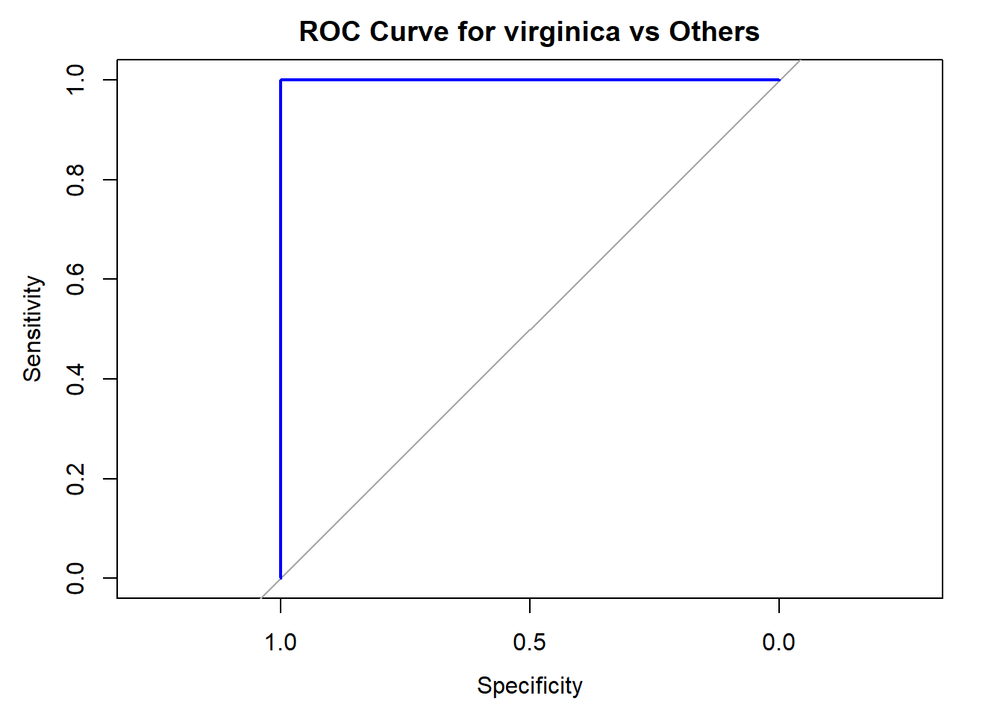

# AUC
auc(roc_virginica)
## Area under the curve: 1
# 2. LDA

lda_model <- lda(Species ~ ., data = train_data)
lda_pred <- predict(lda_model, test_data)$class
cat("\nConfusion Matrix - LDA:\n")
##
## Confusion Matrix - LDA:
cm_lda <- table(Actual = test_data$Species,Predicted = lda_pred)
print(cm_lda)
## Predicted
## Actual setosa versicolor virginica
## setosa 16 0 0
## versicolor 0 16 0
## virginica 0 0 13
lda_acc=mean(test_data$Species==lda_pred)
mean(test_data$Species!=lda_pred)
## [1] 0
# 3. QDA
qda_model <- qda(Species ~ ., data = train_data)
qda_pred <- predict(qda_model, test_data)$class
cat("\nConfusion Matrix - QDA:\n")
##
## Confusion Matrix - QDA:
cm_qda <- table(Actual = test_data$Species,Predicted = qda_pred)
print(cm_qda)
## Predicted
## Actual setosa versicolor virginica
## setosa 16 0 0
## versicolor 0 16 0
## virginica 0 0 13
qda_acc=mean(test_data$Species==qda_pred)
mean(test_data$Species!=qda_pred)
## [1] 0
# 4. kNN (k=5)

knn_pred <- knn(train = train_data[, -5], test = test_data[, -5],
cl = train_data$Species, k = 5)
cat("\nConfusion Matrix - kNN:\n")
##
## Confusion Matrix - kNN:
cm_knn <- table(Actual = test_data$Species,Predicted = knn_pred)
print(cm_knn)
## Predicted
## Actual setosa versicolor virginica
## setosa 16 0 0
## versicolor 0 15 1
## virginica 0 3 10
knn_acc=mean(test_data$Species==knn_pred)
mean(test_data$Species!=knn_pred)
## [1] 0.08888889
# 5. Naive Bayes

nb_model <- naiveBayes(Species ~ ., data = train_data)
nb_pred <- predict(nb_model, test_data)
cat("\nConfusion Matrix - Naive Bayes:\n")
##
## Confusion Matrix - Naive Bayes:
cm_nb <- table(Predicted = nb_pred, Actual = test_data$Species)
print(cm_nb)
## Actual
## Predicted setosa versicolor virginica
## setosa 16 0 0
## versicolor 0 14 1
## virginica 0 2 12
nb_acc=mean(test_data$Species==nb_pred)
mean(test_data$Species!=nb_pred)
## [1] 0.06666667
# Accuracy calculations

cat("\nAccuracy Summary:\n")
##
## Accuracy Summary:
cat("GLM Accuracy: ",model_acc, "\n")
## GLM Accuracy: 1
cat("LDA Accuracy: ", lda_acc, "\n")
## LDA Accuracy: 1
cat("QDA Accuracy: ", qda_acc, "\n")
## QDA Accuracy: 1
cat("kNN Accuracy: ", knn_acc, "\n")
## kNN Accuracy: 0.9111111
cat("Naive Bayes Accuracy: ", nb_acc, "\n")
## Naive Bayes Accuracy: 0.9333333
cat("Conclusion: The iris dataset is linearly separable, so linear methods (LDA, logistic regression) and neighborhood-based methods (kNN) are most effective.")
## Conclusion: The iris dataset is linearly separable, so linear methods (LDA, logistic regression) and neighborhood-based methods (kNN) are most effective.

